1st December 2017

**Yokohama Rubber and YOKOHAMA Magokoro (Sincere Heart) Fund Donations Support Relief Efforts in Mexico Following Recent Strong Earthquakes**

YOKOHAMA Rubber and the YOKOHAMA Magokoro (Sincere Heart) Fund, established as a social contribution fund supported by employees, donated a total of 145,000 Mexican pesos (about ¥1 million) in October to the Mexican Red Cross to support relief efforts in areas damaged by a series of strong earthquakes this past September.  
  
YOKOHAMA expresses the sincerest sympathies to everyone suffering from the damages caused by these earthquakes, and pray for a speedy recovery in the damaged areas and return to normal lives.  
  
The YOKOHAMA Magokoro (Sincere Heart) Fund was established in May 2016 to make donations to help fund disaster relief efforts and to provide financial support for NPOs, NGOs and other nonprofit organizations working on contribution to society such as to conserve the environment and protect human rights. The Fund is supported by Yokohama Rubber employees who voluntarily contribute part of their monthly salary in units of ¥100. Yokohama Rubber matches the donations made by the Fund, thus doubling the financial support extended to people, communities and organizations in need of assistance.

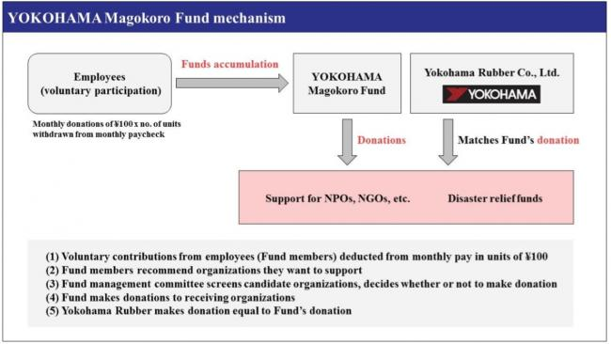

*YOKOHAMA Magokoro Fund mechanism*